

Saint Louis University
Graduate Program, School of Nursing
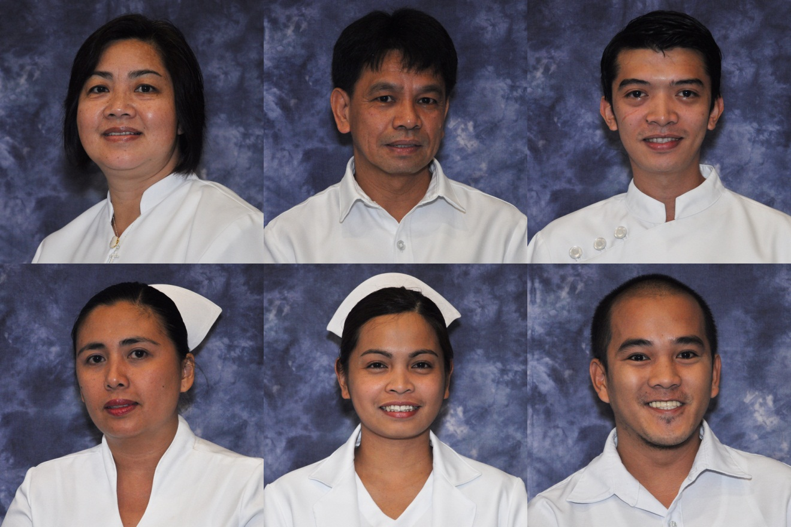

Curriculum Vitae

Name: Cabansag, Marites Casino
(Family Name) (First Name) (Middle Name)
Date of Birth: April 3, 1970 Place of Birth: San Fernando, Pampanga
Nationality: Filipino Gender: Female Height: 5 Feet
Civil Status: Married Name of Spouse: Jose C. Cabansag, Jr.
PRC License No: 0185134 TIN: 164- 173- 793 SSS No: 33-1399087-5 Phil Health No: 04-025002253-2 PAG-IBIG No: 1290-0055-2677
Baguio Address: 103 Idogan Village, San Carlos Heights, Baguio City
Home Address: 103 Idogan Village, San Carlos Heights, Baguio City
Contact Nos: CP No. 0910-256- 5038 Land Line: None
Email Address: mcc4370@yahoo.com

EDUCATIONAL BACKGROUND: (from ELEM to COLLEGE/POST-GRAD)
LEVEL | SCHOOL | YEAR GRADUATED/  UNITS EARNED | DEGREE
Elementary | St. Louis School of Campo Filipino | 1983 | Primary
High school | St. Louis School of Campo Filipino | 1987 | Secondary
College | Pines City Educational Center | 1991 | Bachelor of Science in Nursing
Post-graduate | Philippine Colleges of Health Sciences, Inc | 2006 | Master of Arts in Nursing Major in Nursing Administration & Management
Post- graduate | St. Louis University | 42 units earned  finished comprehensive examination last march- april 2015 | Doctor of Philosophy in Nursing

WORK EXPERIENCE: (From Present to Past)
YEAR | POSITION | COMPANY/INSTITUTION
1995- 2001;  1992- 1993 | Staff Nurse | Pangasinan Medical Center
2001- 2004;  1993- 1994 | Faculty/ Clinical Instructor | Pines City Colleges/ Pines City Educational Center
2011- 2014 | Department Head Level 2  Faculty/Clinical Instructor | St. Louis University
2014 UP TO THE PRESENT | Level 1, 2, 3, & 4 Clinical Instructor/ Faculty | St. Louis University

PROFESSIONAL ORGANIZATION MEMBERSHIP or AFFILIATIONS
NAME OF ORGANIZATION | POSITION
Philippine Nurses Association | Member
Philippine Nursing Research Society, Inc | Member

RESEARCH INVOLVEMENT
- FACULTY RESEARCH (SY June 2009- March 2016)
DATE | TITLE | SPONSORING AGENCY | ROLE
June 2008-2009 | Caregiver's Perception on Bullying | Group research:  under-graduate | Research adviser/ promoter
June 2009- 2010 | Knowledge of Mothers on the Garantisadong Pambata Program | Group research:  under-graduate  SLU- SON | Research adviser/  promoter
June 2010-2011 | Working Scholars: Climbing the Ladder of Success | Group research: under-graduate SLU- SON | Research adviser/ promoter
June 2011-2012 | Knowledge of Mothers on Prevention of Osteoporosis | Personal thesis; Masters student  SLU- SON | Thesis adviser
August 2014-2015 | Factors Affecting the Compliance of Families on the Garantisadong Pambata Program in Baguio City | Group research: under-graduate | Research adviser/ promoter
August 2015- 2016 | Non-traditional Families: Prevalence & its Effects on Nutrition and Aggressive Behavior | Group research:  under-graduate | Research promoter/mentee
August 2016- may 2017 | Perceived Disaster Response Capacity among Elementary Teachers in Baguio City | Group research:  under-graduate | Research promoter/mentee

B. RESEARCH PRESENTATIONS (SY June 2009- March 2016)
DATE | TITLE | SPONSORING AGENCY | ROLE
February 2012 | Working Scholars: Climbing the Ladder of Success  (research presentation) | SLU- SON research committee | Research adviser
March 2016 | Compliance of Families on the Garantisadong Pambata Program in Baguio City  (poster presentation) | ADCPN-CAR | Research promoter
March 2017 | Non-traditional Families: Prevalence & its Effects on Nutrition and Aggressive Behavior | ADCPN with SLU-SON | Research mentee

C. PUBLICATIONS (Since 2005- March 2016)
TITLE | JOURNAL/PAPER | DATE
None | n/a | n/a

D. OTHER RESEARCH INVOLVEMENT (SY June 2009- March 2016)
TITLE | SPONSORING AGENCY | DATE AND VENUE | ROLE
14th Regional Nursing Research Congress: Ethics in Writing and Publication of Research | SLU- SON research committee | February 16, 2013  Prince Bernhard Hall, SLU | Member of working committee
Scientific Session: Role of Nurses in Infection Control & Nurse as Patient Advocate | SLU- SON in coordination with SLU- CON alumni | January 17, 2014  SLU- Center for Culture and the Arts (CCA)theater | Member of working committee
15th Regional Nursing Research Congress | SLU- SON | February 15, 2014  Gerard Decaestecker, Navy Base, B.C. | Member of working committee
Use of Emergency Equipment in Emergency Cases at SLU (stretcher) | SLU- SON Quality Improvement Project | August- December 2015 | Quality Improvement Project adviser
Hair Mercury Levels of Pocket Mining Communities in CAR | DOST, PCHRD | November 2015 up to June 2016 | Project research assistant
Emergency Equipment Resource Signage | SLU- SON Quality Improvement Project | August 2016 to May 2017 | Quality Improvement Project adviser
Different thesis & non-thesis research outputs  (dates cannot be remembered anymore) | SLU- SON graduate school | Different dates but during the past 5 years | Panel/ adviser

EXTENSION AND OUTREACH (SY June 2009- March 2016)
TITLE | SPONSORING  AGENCY | DATE &  VENUE | ROLE
Jobs fair for Louisian Nurses 2011 | SLU- SON | 2011- 2015  Prince Bernhard Gym, SLU | Member of working committee
We Care Medical Mission  “Tuloy-tuloy ang Serbisyong Totoo para sa Baguio” | SLU- SON;  BGH- MC;  Group of City Councilor Aliping | October 27, 2013  Irisan Elementary School, Irisan, B.C. | Member of health education class conducted on hygiene
Acute Respiratory Infection Extension Program | SLU- SON | May 18, 2014 up to the present | Member
Disaster & First Aid- training of Maryhurst Seminarians | SLU- SON;  EMT/EMS- Baguio  Fire Department | July 1- 2, 2014  Maryhurst Seminary | Facilitator/  trainor
Handog ng SLU sa Baguio Medical Mission | SLU | December 1, 2015  Burnham Park, B.C | Facilitator of level 2 activities
War against Superbugs through Handwashing (handwashing facts) | SLU Medical Clinic in Coordination with PAMET (Philippine Association of Medical Technologists) | April 1, 2016  SLU main campus  (Adenauer building) | Facilitator on handwashing activities  (demonstration & return demonstration)

SPECIAL TRAINING/S RELATED TO PROFESSION SY June 2009- March 2016)
DATE | TITLE OF TRAINING | VENUE/INSTITUTION
September 9- 13, 2013 | Preparing for Institutional Evidence-Based Practice- Implementation | SLU/ Commission on Higher Education Center of Development in Nursing Education
November 24, 2013 | Basic Life Support | Cobalt Building, BGHMC Compound, B.C.
June 14- 15, 2014 | Outcome- Based Education Training | A- 504, SLU
July 8-9, 2014 | Training on Strengthening SLU Disaster teams & health brigade teams in celebration of the National Disaster Consciousness Month | Prince Bernhard Gym,  SLU, B.C.
October 8- 20, 2014 | Finishing Course for Medical Transcriptionist | SLU/Center for technical Excellence Integrated School, Inc  Baguio City

SEMINARS ATTENDED as a PARTICIPANT (SY June 2011- March 2016)
TITLE OF SEMINAR | SPONSORING AGENCY | DATE/VENUE
Physical Assessment & MS tool Integrated | SLU- SON FED committee | March 30, 2011  A- 503, SLU
Table of Specifications: Test Question Construction | SLU- SON FED committee | September 8, 2011  A- 503, SLU
8th PNAA International Convention- Balikturo Program: Trends in Nursing Practice | Philippine Nurses Association of America Foundation, Inc in Coordination with Philippine Nurses Association of Maryland Chapter (PNAMC) & SLU- SON Philippines | February 2, 2012  Prince Bernhard Gym, SLU
Experimental & Qualitative Research Design | SLU- SON research committee | September 2, 2012  CCA theater, SLU
An Introduction to NVIVO: A user’s perspective | PNRS in coordination with SLU- SON | November 24, 2012  R- 408, SLU
Nursing Research & Innovation | PNRS | November 28, 2012  MTC gymnasium, Dona Tytana tower, manila tytana Colleges, Pasay City, Manila
2nd International Conference on Qualitative Research in Nursing and Health: Adventures in Qualitative Research; Traversing with Trustworthiness Evidence-based practice | Philippine Nursing Research Society, Inc  (PNRS) | November 29-30, 2012  Bay Leaf Hotel, Intramuros, Manila, Philippines
Trends in Psychiatric Nursing & Cardiac Catheterization & Legal Aspects of Documentation | SLU- SON in coordination with SLU- SON alumni association | January 19. 2013  CCA theater, SLU
4th JBL Lecture Series: Transformational Leadership: Paradigm Shifts in Nursing | SLU- SON in coordination with SLU-research committee | January 19, 2013  CCA theater, SLU
Trends in Psychiatric Nursing & Cardiac Catheterization & Legal Aspects of Documentation | SLU- SON in coordination with SLU- SON alumni association | January 19. 2013  CCA theater, SLU
14th Regional Nursing Research Congress: Ethics in Writing and Publication of Research | SLU- SON research committee | February 16, 2013  Prince Bernhard Hall, SLU
Basic Life Support | BGH-MC in Coordination with SLU- SON | November 24, 2013  Cobalt Bldg, BGH-MC Compound, B.C.
Research Designs & their Respective Statistical Methods | Research & Extension Office, SLU | December 13, 2013  Burgos Conference Room, Administrative Bldg, SLU
Turnitin- Anti Plagiarism Orientation | Igroup, Lib Tech, & Turnitin | November 26, 2013  Perfecto 7th Floor AVR
We Care Medical Mission: Tuloy-tuloy ang Serbisyong Totoo para sa Baguio | Baguio Congressman’s Social Responsibility Foundation, Inc | October 17, 2013  Irisan Elementary School, Irisan, B.C.
National Tuberculosis Program Orientation for Clinical Instructors | Health Services Baguio, Baguio Health Department | Ooctober 23, 2013  Health Services Office
Forum on Evidence-based Nursing Practice | SLU- SON in coordination with the Commission on Higher Education Center of Development in Nursing Education | September 6, 2013  Jose Burgos Building, Presidential Board Room, SLU
Preparing for Institutional Evidence-based Practice Implementation | SLU- SON in Coordination with the Commission on Higher Education Center of Development in Nursing Education | September 13, 2013  S-504, SLU
Table of Specifications: Test Construction Strategies | SLU- SON FED committee | April 3, 2013  R-601, SLU
Review of IMCI | SLU- SON FED committee | April 3, 2013  Rizal Building 408, SLU
Enhancing Competency in Utilizing Health Assessment Tools | SLU- SON FED committee | April 19, 2013  A- 503, SLU
International Trends in Nursing Specialties: A Closer Look at Nursing Roles & Challenges | SLU- SON in Coordination with SLU- CON Alumni Association  Batch 1994 | January 8, 2014  SLU- Center for Culture and the Arts Theater
Scientific Session: Role of Nurses in Infection Control and Nurses as Patient Advocate | SLU- SON in coordination with SLU- SON Alumni Association | January 17, 2014  SLU- Center for Culture and the Arts Theater
Construction of a Survey Questionnaire | Research and Extension Office, SLU | January 17, 2014  Burgos Conference Room, Administrative Center, SLU
5th JBL Lecture Series | SLU- SON in Coordination with SLU- CON Alumni Association | January 17, 2014  SLU- Center for Culture and the Arts Theater
Understanding Magnet Hospital | SLU- SON in Coordination with SON Graduate Program | January 29, 2014  S- 503, SLU
Transitional Nursing | SLU- SON Graduate School | February 5, 2014  A-503, SLU
11th Post Graduate Course for Physicians, Nurses & Midwives: the Filipina in full circle | Department of Obstetrics and Gynecology- SLUHSH in Cooperation with Baguio-Benguet Medical Society | February 8- 9, 2014  Crown Legacy Hotel, Kisad Rd., B.C.
Comprehensive Course Evaluation of Nursing Core Competencies | SLU- SON FED committee | February 25, 2014  A-504. SLU
Outcome-based Education in the BSN Curriculum | SLU- SON FED committee | June 13-14, 2014  A-503, SLU
First Aid Training Seminar | SLU- SON in Coordination with Maryhurst Seminary | July 1-2, 2014  Maryhurst Seminary, Lucnab, B.C.
Training on Strengthening SLU Disaster Teams & Health Brigade Teams in Celebration of the National Disaster Consciousness Month | SLU Medical Clinic in Coordination with EMS/Health Emergency Mngt, BGH-MC | July 9, 2014  Prince Bernhard Gym, SLU
Aligning Nursing Skills with Outcome-based Education | SLU-SON FED committee | August 1-2, 2014  A- 503, SLU
Revisiting Outcome-based Education and Assessment of Teaching Strategies | SLU- SON FED committee | January 17, 2015  A-503, SLU
6th Jesusa B. Lara (JBL) Lecture Series:  Nursing Scholarship in ASEAN Perspective | SLU-SON in Coordination with SON Alumni Association | March 15, 2015  Gerard Decaestecker Conference Hall, Navy Base Campus, B.C.
Scientific Session:  New Trends and Nurse’s Roles in Cardiovascular & Renal Nursing | SLU- SON in Coordination with SON Alumni Association | March 15, 2015  Gerard Decaestecker Conference Hall, Navy Base Campus, B.C.
5th Annual Convention & Scientific Meeting:  Perioperative Nurses Keeping the Lead | Operating Room Nurses Association of the Philippines Inc (ORNAP)  Baguio-Benguet Chapter | December 6, 2015  Venus Parkview Hotel, B.C.
Mother-baby Friendly Hospital Initiative & Breastfeeding | BGH-MC Mother Baby Friendly Hospital Initiative/Breastfeeding Committee | February 23, 2016  BGH-MC Under Five Conference Room
17th Regional Nursing Research Congress:  Enhancing Nursing Research Competencies towards Global Competitiveness | SLU- SON in partnership with ADCPN- CAR | March 23, 2016  Decaestecker Hall, SLU, B.C.

SEMINARS ATTENDED AS A RESOURCE SPEAKER(SY JUNE 2011- MARCH 2016)
TITLE OF SEMINAR | SPONSORING AGENCY | DATE/VENUE
Research Updates: Research Design | Pines City Colleges, College of Nursing, B.C | March 9, 2013  PT- AVR, Pines City Colleges
Comprehensive Course Evaluation of Nursing Core Competencies | SLU-SON FED | February 25, 2014  A-503

SUBJECTS TAUGHT
UNDERGRADUATE LEVEL | GRADUATE LEVEL
Organization and Management | Comparative Health Care Systems
Nursing Research RLE
NCM 102a Skills Lecture & Return Demonstration
NCM 101a Skills Lecture & Return Demonstration
Basic Nutrition Lecture & Laboratory
Health Ethics in Nursing
Community Health Nursing Lecture and Skills Lecture
NCM 100a Skills Lecture & Return Demonstration
Teaching Strategies in Nursing Education
Physical Assessment Skills Lecture & Return Demonstration
Health Care I & II Lecture & Laboratory

